Bridge
Team Manual — how we use it, day to day
For everyone at the company · July 2026

Contents

The basics (everyone)
- Logging in — open the Bridge link in any browser — phone or laptop — and sign in with your work email. Stay logged in; it remembers you.
- Finding anything — press ⌘K (Mac) or Ctrl+K (Windows), type what you want — “payroll”, a person’s name — and press Enter.
- The bell — your inbox for everything: approvals decided, checklists assigned, review cycles, payslips. Tap any alert — it opens the exact page.
- The ? button — every page has a “How this tab works” note in plain language. When unsure, start there.
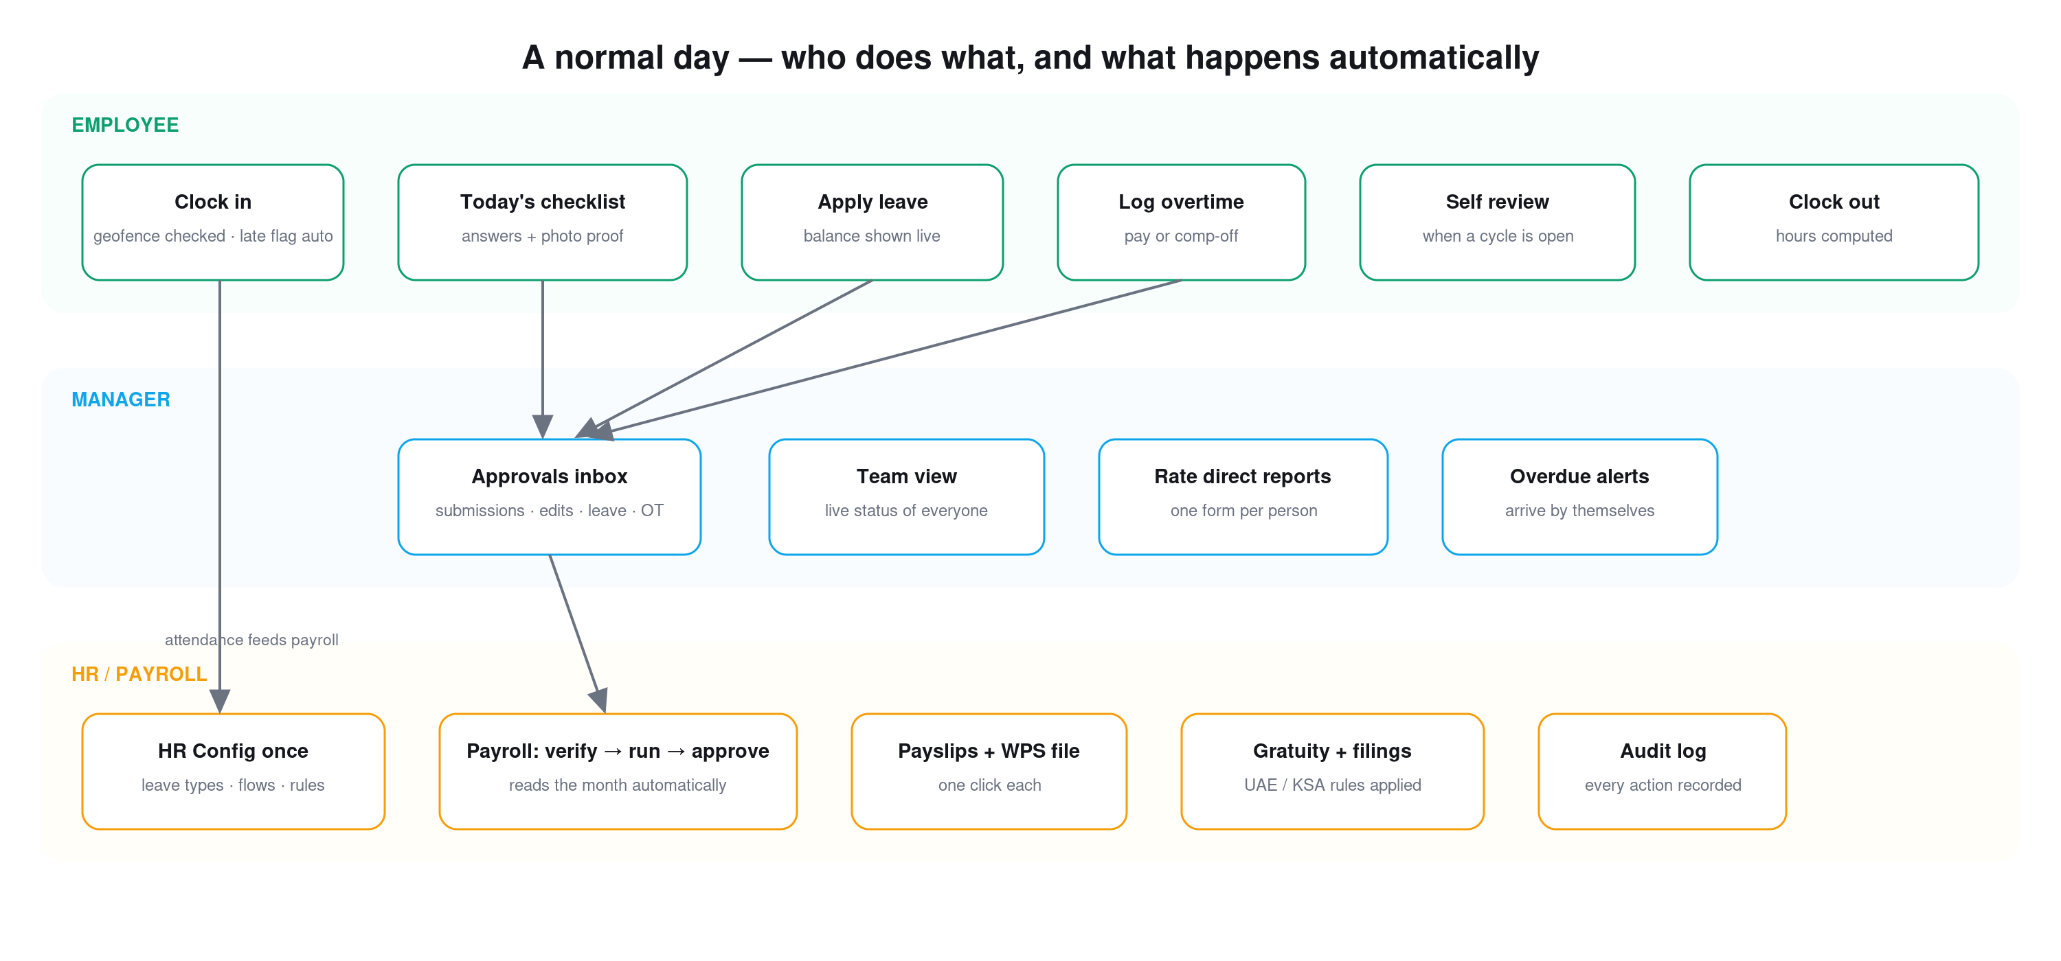
Your day at a glance — employee on top, manager in the middle, HR below.

For every employee

Clocking in and out
- Dashboard → big green button. If your office has a location fence, be inside it. Late arrivals are flagged automatically — no arguments either way.
- Forgot to clock out? The day closes automatically at midnight and your manager is informed — better to remember.

Working from home
- Tap “Mark today as WFH” before you clock in. Your manager is notified, and it shows in the who’s-in board.
- Once you clock in, the WFH tag locks for the day (🔒) — it cannot be changed afterwards, so set it first.

Your checklists
- My Checklists shows what is due today. Answer every question; the camera icon means photo proof is required — the app will not submit without it.
- Miss the due time and the card turns LATE (red). It still must be done — lateness is recorded, not punished by the app.
- Need to fix something already submitted? Request an edit — your manager approves it first.

Leave
- Leave tab shows every balance live — what you have, what is pending. Apply in seconds; you always see which stage your request is at and who it is waiting on.
- Sick leave must start today (that is policy, the form enforces it). Other types can be planned ahead.
- Cancel a pending request any time — the reserved days return instantly.

Overtime, reviews, tickets, letters
- Overtime: log extra hours; your manager approves them as payment (next payroll) or comp-off (extra leave).
- Reviews: when a cycle opens you get a “Fill now” card — rate yourself 1–10 honestly; you will see your manager’s ratings next to yours when it closes.
- Tickets: anything broken or needed — raise it, track it, see who resolved it and why.
- Letters: request a salary certificate or similar; HR approves and issues a print-ready letter on the company letterhead.

For managers
- Inbox — Approvals is your one queue: submissions, edit requests, leave, overtime. Decide there, never in chat. Every decision notifies the person automatically.
- You cannot approve your own requests — the app blocks it, for everyone, including admins.
- Team view shows everyone’s live checklist status; the dashboard Pulse strip counts everything waiting for you.
- Shifts: plan the week as drafts, publish once — everyone is notified and sees only their own shifts.
- Reviews: when a cycle includes manager reviews, you get one form per direct report. The gap between self and manager scores is the conversation starter.
- Overdue alerts come to you by themselves — no chasing needed.

For HR / Admin

People and access
- Users: add people, set their manager, office and salary. Each person gets exactly one role.
- Access Control → Roles: a role is a bundle of switches. Use the search box, the ALL ON / ALL OFF group buttons, and the live “X of Y permissions” counter. Changes apply on Save.
- One-off exceptions: Access Control → People → Personal — overrides beat the role, even for admins.

HR Config (set once, adjust rarely)
- Policy: grace minutes, auto clock-out, leave-year basis. Leave Types: entitlements and accruals per country profile. Holidays: the public calendar.
- Approval flows: who approves leave, in what order — stranded requests auto-escalate to HR/Admin.
- Letterhead & payslip: upload header/footer images, edit the payslip template (a complete default is built in).
- Compliance: currency, WPS employer IDs, gratuity tiers per country (UAE and KSA presets); map each office to its country. Everything here is informational — it never changes net pay.

Payroll month
- Open Payroll — the month is already assembled from attendance, leave and overtime.
- Verify every line (✓), fix data at the source if something looks wrong — then Run.
- Approve (Head of People) → Finalize. Finalize locks the month and notifies everyone their payslip is ready.
- Export the WPS bank file and, when needed, the gratuity liability CSV. Roll back is available until Finalize.

Communication
- Announcements go to everyone, with read tracking. Review cycles: create, watch the progress bar, close, export CSV.
- Settings → Notifications: the email master switch, per-event toggles and every template (subject, wording, button) — edit freely; per-person opt-outs are respected automatically.
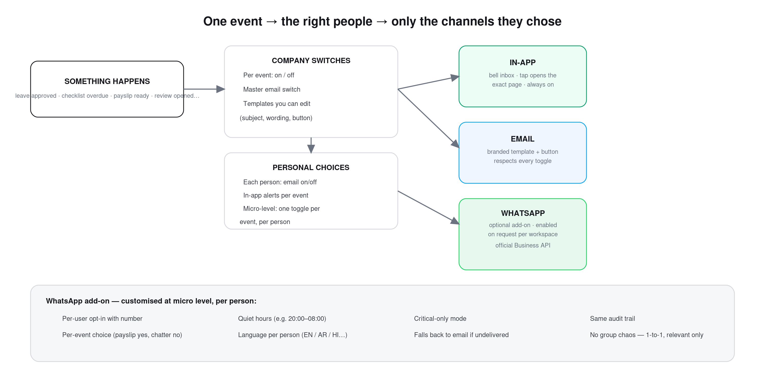
Company switches + personal choices decide the channels. WhatsApp is an optional add-on, enabled on request.

If something looks wrong
- “No office location configured” when clocking in — your account has no office assigned or the office has no location set. Tell HR — it is a 1-minute fix in Locations / your profile.
- A page looks stale or odd — hard refresh once: Ctrl+Shift+R (Windows) or Cmd+Shift+R (Mac). Bridge updates itself; a stubborn old tab occasionally needs the nudge.
- “Some changes didn’t save” appears repeatedly — your login token likely expired while the tab slept. Refresh the page — your work is kept locally and syncs the moment you are back in.
- You believe you lack access you should have — ask your admin to check your role in Access Control — permission changes apply instantly.
- Anything else — raise a Ticket in Bridge itself — that is what it is for. You will see exactly who picked it up and what they did.

Admin day-1 checklist
- Add offices in Locations; set the geofence (location + radius) for each.
- Create departments; add people with manager, office, joining date and salary.
- Check each person’s role in Access Control; make custom roles if the built-ins do not fit.
- Review HR Config: leave types for your country profile, public holidays, approval flow.
- Upload the letterhead images and check the payslip preview.
- Map each office to its country in HR Config → Compliance; enter WPS employer IDs.
- Keep the email master switch OFF until templates read the way you want — then switch on.
- Run one full week — clock-ins, one checklist, one leave request — before rolling payroll.

